
Holy Cross College

Semester 2 Examination 2017

Multiple Choice Booklet

Year 10 Science
Please place your student identification label in this box
(General)
Physics

Student Name
Student’s Teacher

Time allowed for this paper

Reading time before commencing work: 10 minutes
Working time for paper: 100 minutes

Materials required/recommended for this paper

To be provided by the supervisor

This Question/Answer Booklet
Data Sheet

To be provided by the candidate

Standard items: pens, pencils, eraser, correction fluid, ruler, highlighters.
Special items: non-programmable calculators satisfying the conditions set by the School Curriculum and Standards Authority for this course.

Important note to candidates

No other items may be taken into the examination room. It is your responsibility to ensure that you do not have any unauthorised notes or other items of a non-personal nature in the examination room. If you have any unauthorised material with you, hand it to the supervisor before reading any further.
SECTION 1 MULTIPLE CHOICE (30 marks)

Make a choice of answer and mark it with a cross on the answer sheet in the answer booklet.

1. Calculate the velocity of a bus that travels between two traffic lights 145 metres apart in
20.0 seconds.

(a) 7.00 m/s
(b) 7.25 m/s
(c) 6.25 m/s
(d) 7.50 m/s

2. Acceleration is defined as:

(a) the rate of change of speed.
(b) the rate of change of displacement.
(c) the rate of change of distance.
(d) the rate of change of velocity.

3. A decreasing rate of change of velocity could be called:

(a) positive acceleration.
(b) negative velocity.
(c) deceleration.
(d) braking.

4. In the absence of air resistance:

(a) heavier objects would accelerate toward the ground faster than lighter ones.
(b) more streamlined objects would accelerate toward the ground faster than less streamlined ones.
(c) all objects regardless of mass would accelerate toward the ground with the same velocity.
(d) objects with more mass would accelerate toward the ground faster than objects with less mass.

5. What is the acceleration of a car if it increases its velocity from 5.00 m/s to 15.0 m/s in
4.00 s?

(a) 2.50 m/s²
(b) 2.50 m/s
(c) 150 m/s²
(d) 5.20 m/s²

6. The diagram below shows the four forces acting on a van travelling along a straight, flat road. The forces are:

R = total resistance force; T = driving force; U = upward force of ground on van;
W = weight of van.
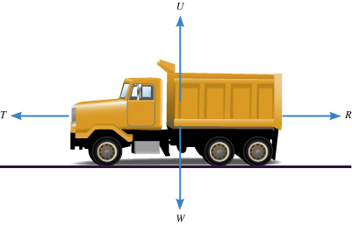
At one time, the van is speeding up (accelerating) in the forward direction. Which of the following best describes the forces at this time?

(a) U = W
(b) U = W; T < R
(c) U = W; T = R
(d) U = W; T > R

7. A balloon is inflated. When released, it rapidly speeds up. Which of the following best describes the force that causes the balloon’s motion?

(a) The push of the air in the room on the escaping air.
(b) The push of the escaping air on the air in the room.
(c) The push of the balloon on the escaping air.
(d) The push of the escaping air on the balloon.

8. You are watching a video of a passenger standing in a tram. Suddenly the passenger topples backwards. Which of the following best describes the motion of the tram at this moment?

(a) The tram starts moving forward.
(b) The tram starts moving backward.
(c) The tram is moving forwards and it starts to slow down.
(d) The tram is moving backwards and it starts to speed up.

9. Which of the following is NOT a true statement about your inertia?

(a) It tends to keep you stationary when a force acts on you.
(b) It is a force that keeps you moving at a constant speed.
(c) It tends to keep you moving in a straight line.
(d) It tends to resist any acceleration.

10. An object accelerates at 2.5 m/s² under a nett force of 20 N. What is the mass of the object?

(a) 0.25 kg
(b) 6.0 kg
(c) 8.0 kg
(d) 50 kg

11. A basketball player crouches down, and then stretches his legs to spring into the air. Which of the following best describes the size of the force of the ground on his feet while he is rising from the crouched position? (Note - he has not left the ground.)

(a) Greater than the force of his feet on the ground.
(b) Equal to the force of his feet on the ground.
(c) Equal to the weight of the player.
(d) Zero.

12. How long would a car travelling at a speed of 60 km/h take to cover a distance of 90 km?

(a) 1½ hours
(b) 2 ½ hours
(c) 3 ½ hours
(d) 4 ½ hours

13. Which of the following is NOT a benefit of the ‘crumple zones’ of a vehicle during a crash?

(a) They increase the time taken to stop.
(b) They spread much of the energy of impact.
(c) They absorb much of the energy of impact.
(d) They reduce the risk of injury to any pedestrian struck by the vehicle.

14. An object starts from rest and accelerates at 5.0 m/s². After 4.0 seconds, its speed will be:

(a) 0 m/s.
(b) 10 m/s.
(c) 20 m/s.
(d) 30 m/s.

15. The tendency of an object to resist changes in its motion is called:

(a) inertia.
(b) weight.
(c) friction.
(d) work.

16. Newton’s Law, known as the Law of Inertia, is:

(a) his first law.
(b) his second law.
(c) his third law.
(d) none of the above.

17. "If an object has zero acceleration, the object must be at rest." This statement is:

(a) always correct.
(b) sometimes correct.
(c) never correct.

18. An object is acted upon by a push force of 50 N forwards and a total frictional force of 40 N. The nett force will be:

(a) 10 N backwards
(b) 10 N forwards
(c) 90 N backwards
(d) 90 N forwards

19. The size of the acceleration acting on an object of mass 10.0 kg that has a nett force of 3.0 N acting on it will be:

(a) 13.0 m/s².
(b) 3.3 m/s².
(c) 0.3 m/s².
(d) 30.0 m/s².

20. A cyclist has a weight of 500 N, the road pushes up with 500 N, the push force forwards is
30 N and the friction opposing the motion is 32 N. The cyclist will be:

(a) stationary.
(b) accelerating.
(c) decelerating.
(d) travelling at constant velocity.

21. When you hit a tennis ball with a tennis racquet, the action force is the force of the racquet hitting the ball and the reaction force is:

(a) the ball hitting the racquet.
(b) the jarring force you feel through your hand.
(c) the weight force on the ball.
(d) the weight force on you.

22. Which of the following is NOT a significant benefit of air bags in a collision?

(a) They prevent collisions between occupants and the windscreen.
(b) They prevent collisions between the driver and the steering wheel.
(c) They protect occupants from whiplash injury in rear-end collisions.
(d) They cushion impacts between the occupant and the side of the vehicle.

23. Which of the following does NOT describe a benefit of using a seatbelt in a head-on crash?

(a) It stops the occupant from continuing to move forward when the vehicle stops.
(b) It reduces the risk of whiplash type injury.
(c) It stops the occupant at the same rate as the vehicle.
(d) It prevents the occupant from striking the windshield.

24. Find the final velocity of a cyclist travelling at 3.00 m/s if she accelerates at 1.20 m/s² for
5.00 seconds.

(a) 9.00 m/s
(b) 19.0 m/s
(c) 99.0 m/s
(d) 0.900 m/s

25. An object has a mass of 250 kg . On Earth, it would have a weight closest to:

(a) 2.5 N.
(b) 25 N.
(c) 250 N.
(d) 2500 N.

26. A driver noticed that his speedo reading was 118.8 km/h. Which of the following represents the speedo reading in m/s?

(a) 11880 m/s
(b) 33 m/s
(c) 118 m/s
(d) 330 m/s

27. The change in position of an object and its direction is known as:

(a) displacement
(b) distance
(c) average speed
(d) average velocity

The following diagrams represent the marks made on four separate tapes by the timing device as the cart moves.

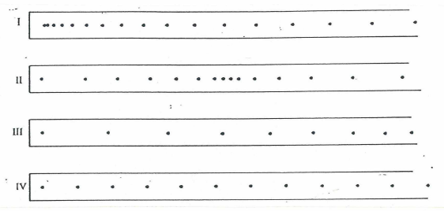

28. Which one of the diagrams best indicates that the cart was slowing down throughout the recorded time interval?

(a) I (b) II (c) III (d) IV

29. Which one of the diagrams best indicates that the cart started from rest and accelerated?

(a) I (b) II (c) III (d) IV

30. Which one of the diagrams best indicates that the cart was travelling at constant speed?

(a) I (b) II (c) III (d) IV

END OF SECTION 1

